**A PROJECT REPORT ON**

**Spam Detection on Mobile Phone Short Message Service(SMS)Performance using FP-growth and Naive Bayes Classifier**

A Project Report submitted in partial fulfilment of the requirement for the award of

Degree of Bachelor of Science

In

Computer Science and Engineering

By

**S BALENIA ROHITHA - 111717013003**



**Department of Computer Science and Engineering**

**Loyola Academy**

Old Alwal, Secunderabad, 500010

(Autonomous and Affiliated to Osmania University)

Re-accredited by “NAAC” with ‘A’

A “College with Potential for Excellence” by UGC

**2019-2020**

**Loyola Academy**

Old Alwal , Secunderabad, 500010

(Autonomous and Affiliated to Osmania University)

Re-accredited by “NAAC” with ‘A’ grade

A “College with Potential for Excellence” by UGC



**CERTIFICATE**

This is to certify that the project entitled “**Spam Detection on Mobile Phone Short Message Service(SMS) Performance using FP-growth and Naïve Bayes Classifier** ” is a record of bonafide work carried out during III year 2nd semester as partial fulfillment for the award of the **DEGREE OF BACHELOR OF SCIENCES IN COMPUTER SCIENCE AND ENGINEERING** during the academic year 2019-20.

The results embodied in this project report have not been submitted to any other University or Institute for the award of any Degree or Diploma

**NAME : S BALENIA ROHITHA**

**CLASS : DCS**

**UID NO : 111717013003**

HEAD OF THE DEPARTMENT PRINCIPAL

EXTERNAL EXAMINER INTERNAL EXAMINER

*ORGANIZATION PROFILE*

**National Small Industries Corporation Ltd. (NSIC)**, is an ISO 9001-2008 certified Government of India Enterprise under Ministry of Micro, Small and Medium Enterprises (MSME).

NSIC has been working to fulfill its mission of promoting, aiding and fostering the growth of small industries and industry related micro, small and medium enterprises in the country.

Over a period of five decades of transition, growth and development, NSIC has proved its strength within the country and abroad by promoting modernization, upgradation of technology, quality consciousness, strengthening linkages with large medium enterprises and enhancing exports - projects and products from small enterprises.

NSIC operates through countrywide network of offices and Technical Centres in the Country. To manage operations in African countries, NSIC operates from its office in Johannesburg, South Africa. In addition, NSIC has set up Training cum Incubation Centre & with a large professional manpower, NSIC provides a package of services as per the needs of  MSME sector.

NSIC carries forward its mission to assist small enterprises with a set of specially tailored schemes designed to put them in a competitive and advantageous position. The schemes comprise of facilitating marketing support, credit support, technology support and other support services.

# **DECLARATION**

We hereby declare that the project entitled **“Spam Detection on Mobile Phone Short Message Service(SMS) Performance Using FP-growth and Naïve Bayes Classifier”** done by **S BALENIA ROHITHA (111717013003)** submitted is a record of an original work done by us.

The project has been successfully completed and submitted in partial fulfillment of the requirements for the award of **“DEGREE OF BACHELOR OF SCIENCE IN COMPUTER SCIENCE AND ENGINEERING”** from **“LOYOLA ACADEMY”** affiliated to **“Osmania University, Hyderabad”** in the authentic way and has not been submitted in any other university or institution for the award of any degree or diploma.

**S BALENIA ROHITHA**

**(111717013003)**

**ACKNOWLEDGEMENT**

“Task successful” makes everyone happy. But the happiness will gold without glitter if we didn’t state the persons who have supported us to make a success.

Success will be crowned to people who made it reality but people who constant guidance and encouragement made it possible crowned first on the eve of success.

This acknowledgement transcends the reality of formality when we would like to express deep gratitude and respect to all those people behind the screen who guide, inspire and helped us for the completion of our project work.

I would like to express our thankfulness to our project guide **MRS.G.PREETHI**, Head of the Department for her constant motivation and valuable help through the project work, and we express our gratitude to for her supervision, guidance and cooperation through the project.

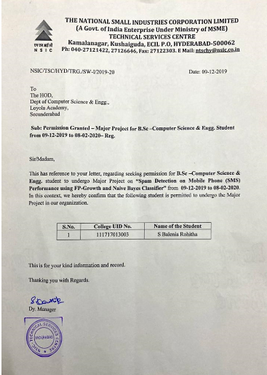

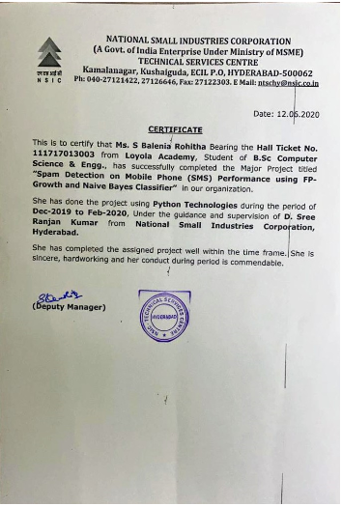

**ABSTRACT**

SMS (Short Message Service) is still the primary choice as a communication medium even though nowadays mobile phone is growing with a variety of communication media messenger applications. However, nowadays along with the SMS tariff reduction leads to the increase of SMS spam, as used by some people as an alternative to advertise and fraud. Therefore, it becomes an important issue as it can bug and harm the users and one of its solutions is with automatic SMS spam filtering.

One of most challenging in SMS spam filtering is its accuracy. In this research we proposed to enhance SMS spam filtering performance by combining two of data mining task association and classification. FP-growth in association is utilized for mining frequent pattern on SMS and Naive Bayes Classifier is used to classify whether SMS is spam or ham. Training data was using SMS spam collection from previous research. The result of using collaboration of Naive Bayes and FP-Growth performs the highest average accuracy of 90%. FP-Growth for dataset SMS Spam Collection and improves the precision score; thus, the classification result is more accurate.

**INDEX**

|  |  |  |
| --- | --- | --- |
| **SNO** | **CONTENTS** | **PAGE NO** |
|  | Abstract | 8 |
| 1 | Introduction | 11 |
| 2 | System specifications  2.1 Hardware requirements  2.2 software requirements | 12 |
| 3 | System Analysis  3.1 existing system  3.2 proposed system  3.3 feasibility study  3.4 modules | 13 |
| 4 | System design  4.1 system Architecture  4.2 uml diagrams  4.2.1 class diagram  4.2.2 use case diagram  4.2.3 sequence diagram  4.2.4 activity diagram | 19 |
| 5 | 5.1 Introduction to Testing  5.2 Dimensions of Testing  5.3 Stages of Testing  5.4 Types of Testing | 34 |
| 6 | Output screens | 46 |
| 7 | conclusion | 52 |
| 8 | Future Enhancement | 53 |
| 9 | References | 55 |
| 10 | Appendix-A | 56 |
| 11 | Appendix-B | 61 |

**SPAM DETECTION ON MOBILE PHONE**

1. **INTRODUCTION:**

Spam Detection system is proposed which will classify the data into spam and ham. A typical data can be classified by filtering its content. The process of spam detection is based on the assumption that the content of the spam is different than the legitimate or ham.

Spam is also referred to as junk and is unsolicited messages sent in bulk by spamming. Spammers collect email addresses from chat rooms, websites, customer lists, newsgroups, and viruses that harvest users' address books.

On top of mocking-up delivery and storing the results you also need to have human analysis of the accuracy of filtering (flagging as spam, deleting, filing to a "Junk E-mail" folder, etc). It probably goes w/o saying, but a human needs to verify the results of filtering since the whole point of this exercise is to test the computer's ability to filter results. (I know, that went w/o saying... but I can just hear somebody saying "But wait! We'll write a script to test the accuracy...")

The filtering analysis is problematic foremost, to my mind, as a matter of scale. For any large group of end-users, filtering analysis is going to be beyond the abilities of an individual or small group of testers (or, more likely, they'll just "spot check" and hope for the best). Moreover, the tester may have a different idea of what should be considered "spam" than the real receiving user (who really *does* want to receive those stupid promotional emails from their car rental company, or the "vocabulary word of the day"). Identifying obviously failed messages is probably pretty easy (poronographic emails in the "Inbox", messages from known Customers in the "Junk E-mail" folder, etc), but there's certainly the potential for subtlety.

I don't think there's a 100% substitute for reality-- you're just going to have to get close and hope that your testing setup reflects reality closely enough to give you an accurate assessment of the filter's performance.

**2. SYSTEM SPECIFICATIONS:**

**Hardware requirements:**

* System : Intel CORE i3
* Hard Disk : 40 GB.

**Software requirements:**

* Operating system : Windows 7/8/10
* Coding Language : Python
* IDE : PyCharm, Python IDLE 2.7/3.6
* Database : CSV File, TSV File.

**3. SYSTEM ANALYSIS**

**3.1 Existing System:**

Now a day’s true caller is that existing system which can block these senders message whose messages are annoying you but we have a control over the sender but not ones the type of messages. So we need such technology/system which can block the particular kind of messages.

In the existing system attackers used shortened malicious URL’s that redirect users to external attack server to cope with malicious tweets several twitter spam detection have been proposed these scheme can be classified into account feature-based , relation feature based , message feature based schemes.

* + 1. **Disadvantages:**

Suppose it a user don’t want any promotional message and it he knows which all users can send him these kinds of messages then he/she can block these senders. But if these blocked users any informational message to the user then user will not be able to receive the message. Great likelihood of unresponsive recipients. Waste of time for sales staff. Waste of money for marketing department. Damaged company reputation. Drop in open and click-through rates for marketing campaigns. The most effective method of email marketing is opt-in email. This is just what it sounds like. It is commercial email sent to people who have specifically indicated a willingness to receive it by opting in somehow. It is specifically targeted to a willing audience, making it the Cadillac of email marketing strategies.

**3.2 Proposed System:**

We are using Machine Learning algorithm (Naïve Bayes Algorithm) to eradicate such problem. In this algorithm model will train the machine by its 70% and 30% of dataset. Through this 70% data our machine will be trained enough to decide which is the SPAM message or which is the HAM message. We have tried to create a system which not only identifies email as a spam or non-spam (also known as Ham) but also which can find a concept present in the e-mail along with the category it falls the most into. We have used different lexical, semantic and syntactic features in order to create the system. We have created a database of emails.

The proposed algorithm is consisting of six main steps.

1. Collect the test emails.
2. Remove the following from emails:
3. Html tags
4. Symbols
5. Unimportant word and remaining are converted in dictionary file
6. Now here using the less algorithm to find the repeated word and list out the total number of word count from the dictionary file.
7. Total number of word count is checked which word are spam and which are ham/non-spam.
8. Collect spam and ham mail are put in the unigram weighted formula to find out whether mails are spam or ham.
9. Total number of word count we process it in the word net dictionary which gives the definition of that word and defined the category.

**3.2.1 Advantages:**

1. we can easily block the unnecessary messages compare to existing system. Then the proposed system will distinguish between SPAM & HAM.
2. we are not supposed to block the users we can just oppose or block that type of least important message without blocking the user. So the users can send any important message.
3. Electronic spam is the most troublesome Internet phenomenon challenging large global companies, including AOL, Google, Yahoo and Microsoft. Spam causes various problems that may, in turn, cause economic losses. Spam causes traffic problems and bottlenecks that limit memory space, computing power and speed. Spam causes users to spend time removing it.
4. Various methods have been developed to filter spam, including black list/white list, Bayesian [classification algorithms](https://www.sciencedirect.com/topics/engineering/classification-algorithm), keyword matching, header information processing, investigation of spam-sending factors and investigation of received mails.
5. This study describes three [machine-learning algorithms](https://www.sciencedirect.com/topics/engineering/machine-learning-algorithm) to filter spam from valid emails with low error rates and high efficiency using a multilayer [perceptron](https://www.sciencedirect.com/topics/engineering/perceptron) model. Several widely used techniques include C4.5 decision tree [classifier](https://www.sciencedirect.com/topics/chemistry/classifier), multilayer perceptron and Naïve Bayes classifier, all of which are used for training data whether in the form of spam or valid emails. Finally, the results are discussed, and outputs of considered techniques are examined in relation to the proposed mode

**3.3 FEASIBILITY STUDY**

The feasibility of the system has been studied from the various aspects like whether the system is feasible technically operationally and economically. The present technology has found to be sufficient to meet the requirements of the system. This system is believed to work well when it is developed and installed hence operational feasibility is achieved since the requirement for the project are easily available where headed with the intention to use the available resource to fulfill the system requirement.

**3.3.1 Technical Feasibility**

The technology needed for the proposed system that we are going to develop is available we can work for the project is done with current equipment existing tools like python we can develop our system using this technology if needed to upgrade in future if we want to use new technology like android app of our system it is possible hence the system that we are going to develop will successfully satisfy the needs of the system

**3.3.2Economic Feasibility**

Since the system is develop as a part of project work there is no manual cost to spend for the proposed system also all the resources are already available it gives an indication the system is economically possible for the development economic justification is generally the bottom line consideration for most systems the cost of conduct a full system investigation is negotiable because required information is collected. We can run our system in our normal hardware like desktop, laptop, mobiles. This system won’t require extra specific software to use it. The project that we are going to develop won’t require enormous amount of money to be developed so it will be economically feasible.

**3.3.3 Operational Feasibility**

The user interface will be user friendly and no training will be required to use the application the solution proposed for our project is operationally workable and most likely convenient to solve the irrelevant document and fraud message.

**3.4 Modules**

* Importing the Libraries
* Load Data sets
* Data Preprocessing
* Feature Extraction (FP-Growth)
* Vector Creation
* Classification
* Naïve Bayes Algorithm
* Finding the accuracy
* Output
* **DATA SET AND RUNNING ENVIRONMENT**:We have manually collected a British English data set consisting of 425 SMS spam messages from the GrumbleText website.The GrumbleText website receives SMS spam reported by volunteer users. However, because of privacy concerns, private data, such as name, address and phone number, have been removed. The SMS are not chronologically sorted. We argue that our data set is reliable for this research. Compared with another public data set [25],** our data set’s messages are in the same language (British English) and from the same society (Britain).
* **FEATURE EXTRACTION:**An English stop word is used to remove meaningless words because these words exist in both e-mail spam and e-mail ham. However, removing such words will reduce the number of useful features to analyze because SMS is very short. As a simple example, we have two SMS spam: “$$$ buy free Viagra!” and “free SMS!”, also one SMS ham: “buy book :p”. We obtain five words: “buy”, “free”, “Viagra”, “SMS”, and “book”. These words then enter the word vocabulary (|v|).
* **VECTOR CREATION:**Vector creation is a process used to map a raw tokenized word into numerical data that is ready to be classified by the text classification algorithm. We propose to use Word Occurrences because of its simplicity as our proposed approach was designed for mobile phones. We just need to count the number of words in each SMS message.
* **NAÏVE BAYES:**Once the word occurrences table is built, we can apply the Naïve Bayes approach to filter unknown incoming SMS. e the probability of SMS ham is higher than the probability of SMS spam, we can say that the SMS is ham. Intuitively, a human will agree that the SMS is ham, not spam, because there is no word, such as “free” or “Viagra”, present that is usually present in SMS spam. However, if the vocabulary count is high and the number of words is high, then the probability value will be too low for the processor to run the mathematical calculation, especially in a mobile phone. This problem is termed the underflow problem.
* **UPDATING FILTERING METHOD**: The feature extraction and vector creation steps are part of the training process. The filtering process step is part of the classification process. If we receive a new SMS and want to update the filtering system, we just need to repeat the feature extraction and vector creation steps. If the word already exists in the word occurrences table, we will just update the word occurrences table. If the word does not exist.

One common method of preventing automated spam postings is to employ a module that injects a captcha into common Drupal forms, like the user registration, comment and contact pages. If the captcha, a visual or auditory challenge, can be completed with the correct response, the user is assumed to be human and not an automated spam-posting process. See the captcha documentation or project pages for two modules that provide this functionality.

* [Mollom](http://drupal.org/project/mollom) was a popular spam filtering service that analyzes content in real-time for spam-like characteristics.  Content identified as spam is blocked, while clean content is processed normally. If Mollom is unsure whether the content is spam, it directs your site to require a successful CAPTCHA completion before the post is accepted. Mollom end of life has been [announced](https://www.mollom.com/eol). As of 2 April 2018, Acquia will no longer actively support or maintain Mollom. After that point in time, the Mollom service will no longer be available.
* For filtering without any external services, the [Spam](http://drupal.org/project/spam) module integrates a Bayesian filter along with some other filtering methods. Spam is only available for Drupal 6 (or below).
* For Drupal 8 the [Statistical Spam Filter](https://www.drupal.org/project/ssf) module exists as an alternative.
* [Honeypot](https://www.drupal.org/project/honeypot) and modules like it use simpler techniques to filter spam without any user interaction, using a series of tests on the form itself.
* These more passive modules are often a good first step towards spam prevention as they don't require any extra user interaction or steps to complete existing forms.
* Anti-Spam module by [Clean Talk](https://www.drupal.org/project/cleantalk) to protect Drupal sites from spam bot registration and spam comments publications thru comment and contact forms. Clean Talk is a SaaS spam protection service for Web-sites.  
  Clean Talk uses protection methods which are invisible for site visitors.  
  Using Clean Talk eliminates needs in CAPTCHA, questions and answers, and other methods of protection, complicating the exchange of information on the site. Clean Talk has an advanced option "Spam Firewall".
* This option allows blocking the most active spam bots before they get access to your website. It prevents spam bots from loading website pages so your web server doesn't have to perform all scripts on these pages.

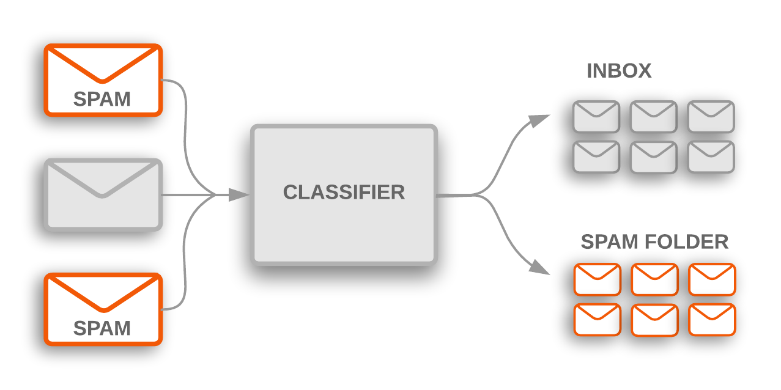

**4 System Design**

**4.1 Input Design:**

Inaccurate input data are the most common causes of sms error in data processing. Errors entered by data entry operators can be controlled by the Input design. "Input design is the process of converting user originated inputs to computer based formats". It consists of developing specification and procedure for data preparation.

**a) Controlling amount of input:** Due to so many reasons, design should control the quantity of data    for input. Reducing the data requirement can lower cost by reducing labour expenses. By reducing input requirement, the analyst can speed the entire process from data capture to providing results to the users.

**b) Avoiding delay:** A processing delay resulting from data preparation or data entry operator is called bottleneck. Avoiding bottleneck should always be one objective of the analyst while designing output.

**c) Avoiding errors in data:** The rate at which sms errors occurs depends on the quantity of data, i.e. smaller the amount of data to input the fewer the opportunities for errors.

**d) Keeping the process simple:** Simplicity works and is accepted by the users. Complexity should be avoided when there are simple alternatives.

**4.2 Output Design:**

The term output necessarily implies to information on printed or displayed by an information system. Following are the activities that are carried out in output design stage.

Ø  Identification of specific output required to meet the information requirements.

Ø  Selecting of methods for processing outputs.

Ø  Designing of reports, formats or other documents that acts as a carrier of information.

**4.2.1 Output Design Activities:**

The output design of an information system must meet the following objectives:

1. The output design should provide information about the past, present or future events. The operational control level outputs provide operations of the past and present events. On the other hand, strategic planning level provides information of the future events.

2. The output design should indicate the important events smserror, opportunities and problems.

3. The output design should be designed keeping in mind that an action must be triggered in response to some event. A set of rule is pre- designed for such trigger.

4. The output design should produce some action to the transaction. For e.g. when the telephone bill is generated, a receipt is printed.

**4.3 System Architecture:**

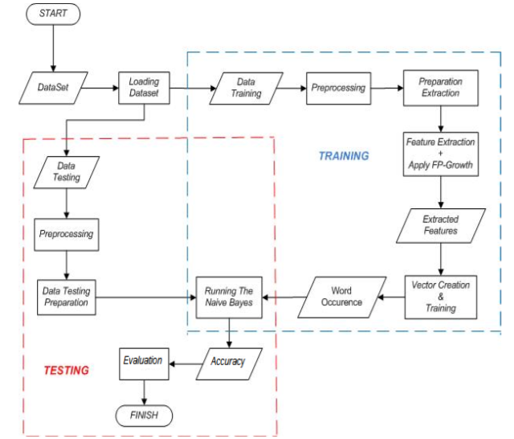

**4.4 UML Diagrams:** A UML diagram is a diagram based on the UML with the purpose of visually representing a system along with its main actors, roles, actions, artifacts or classes, in order to better understand, alter, maintain, or document information about the system.

**4.4.1 Class Diagram**:The class diagram is the main building block of object oriented modeling.It is used for general conceptual modeling of the structure of the application, and for detailed modeling translating the models into programming code.It contain three compartments:

1)The top compartment contains the name of the class.

2)The middle compartment contains the attributes of the class.

3)The bottom compartment contains the operations the class can execute.

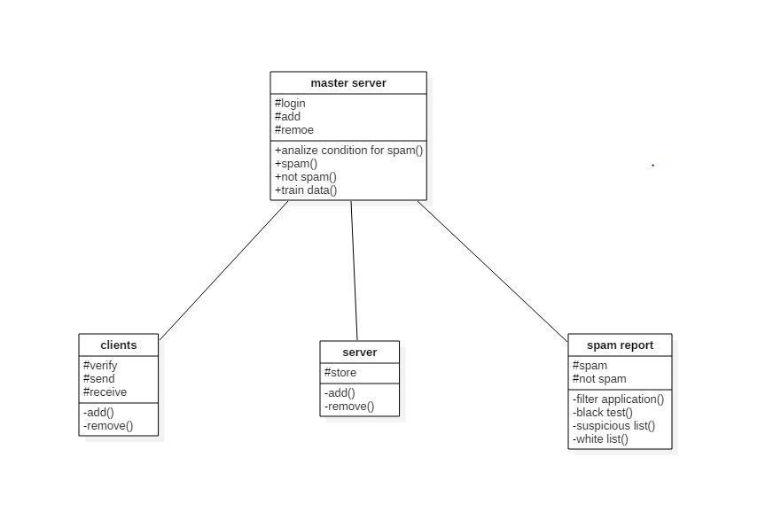

**4.4.2 Use case Diagram:** A use case diagram is a representation of a user’s interaction with the system that shows the relationship between the user and the different use cases in which the user is involved. A use case diagram can identify the different types of users of a system and the different use cases and will often be accompanied by other types of diagrams as well. The use cases are represented by either circles or ellipses.

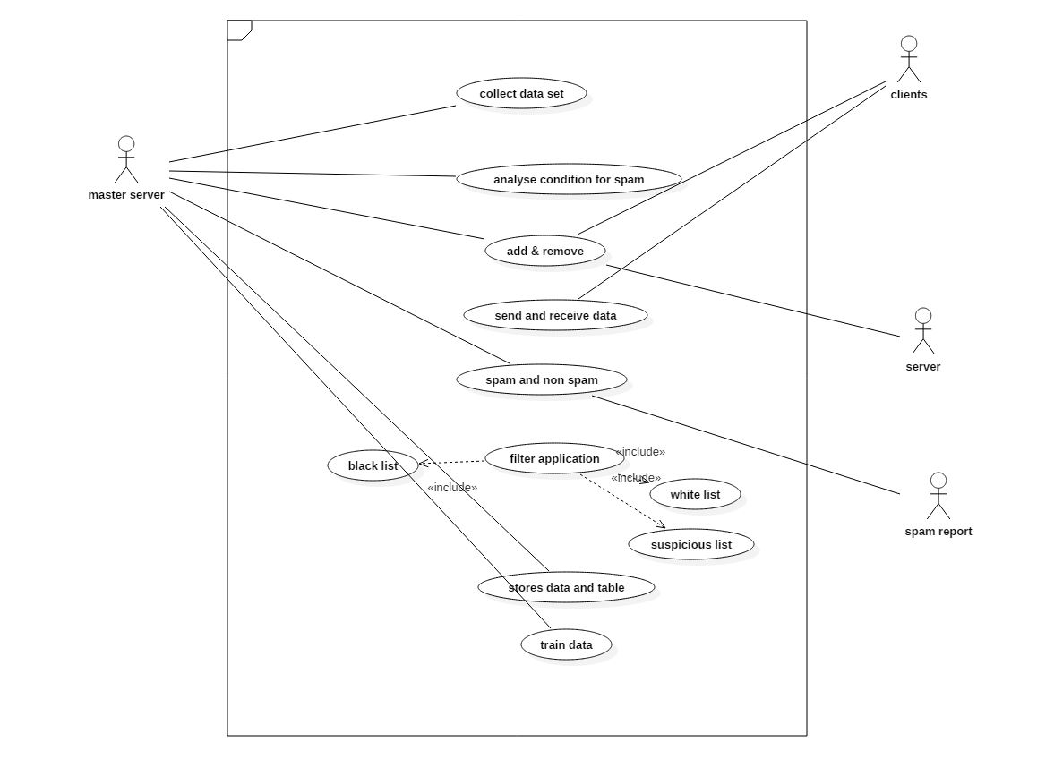

**4.4.3 Sequence Diagram:** A sequence diagram shows object interactions arranged in time sequence. It depicts the objects and classes involved in the scenario and the sequence of messages exchanged between the objects needed to carry out the functionality of the scenario.

A sequence diagram shows, as parallel vertical lines(lifelines), different processes or objects that live simultaneously, and, as horizontal arrows, the messages exchanged between them, in the order in which they occur. This allows the specification of simple runtime scenarios in a graphical manner.

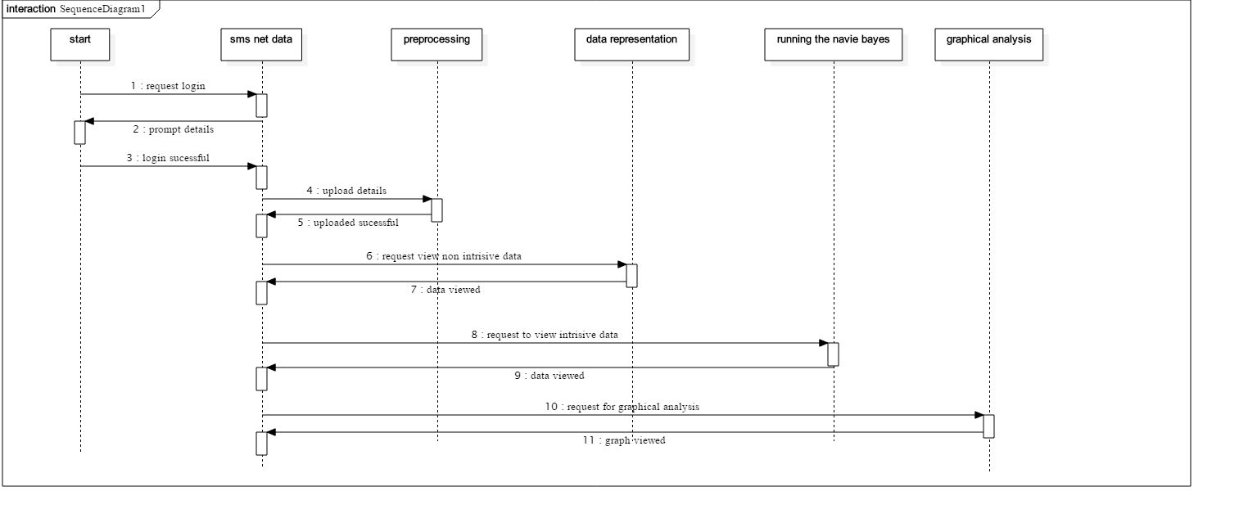

**4.4.4 Collaboration Diagram:** A collaboration diagram, also known as a communication diagram, is an illustration of the relationships and interactions among software objects in the UML. These diagrams can be used to portray the dynamic behaviour of a particular use case and define the role of each object. Collaboration diagrams are created by first identifying the structural elements required to carry out the functionality of an interaction.

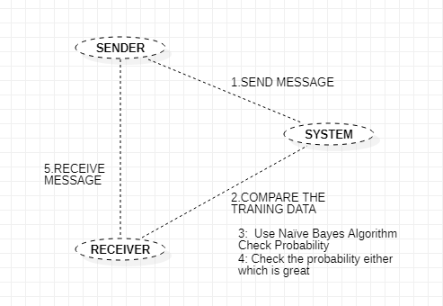

**4.4.5 Activity Diagram:** Activity diagram describe the dynamic aspects of the system. Activity diagram is basically a flowchart to represent the flow from one activity to another activity. The activity can be described as an operation of the system. The control flow is drawn from one operation to another. This flow can be sequential, branched, or concurrent.

The basic purposes of activity diagram is it captures the dynamic behavior of the system. They are also used to construct the executable system by using forward and reverse engineering techniques.

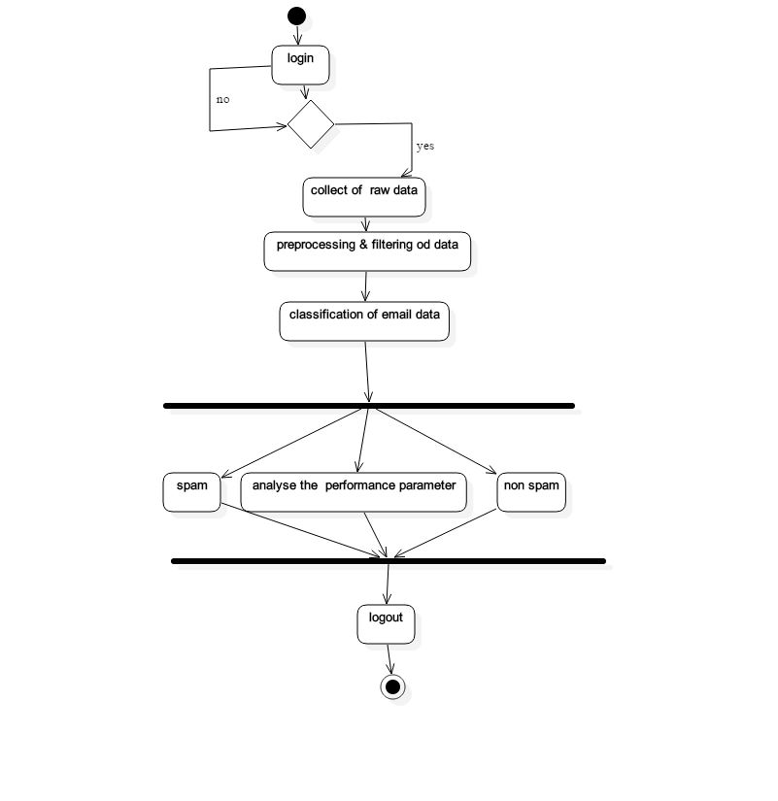

**4.4.6. State Chart Diagram:** State chart diagram is one of the five UML diagrams used to model the dynamic nature of a system. They define different states of an object during its lifetime and these states are changed by events. State chart diagrams are useful to model the reactive systems. Reactive systems can be defined as a system that responds to external or internal events. State chart diagram describes the flow of control from one state to another state.

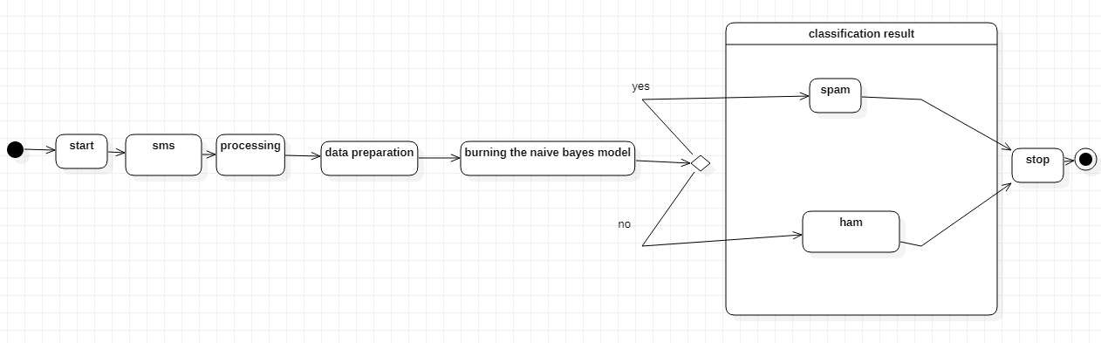

**4.4.7 Component Diagram:** A component diagram depicts how components are wired together to form larger components or software systems. They are used to illustrate the structure of arbitrarily complex systems. These diagrams are also used as a communication tool between the developer and the stakeholders of the system.

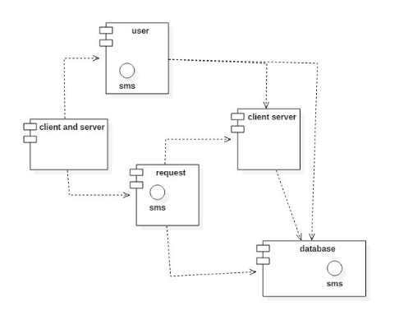

**4.4.8 Deployment Diagram:** A deployment diagram in the Unified Modeling Language models the physical deployment of artifacts on nodes. This diagram shows what hardware components exist, what software components run on each node and how the different pieces are connected.

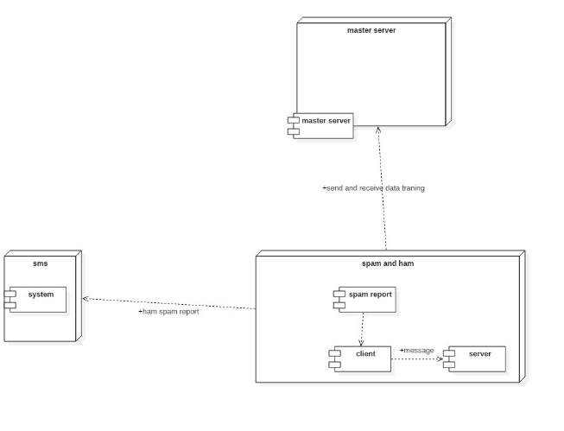

Data Flow Diagram:

**Feature Extraction**

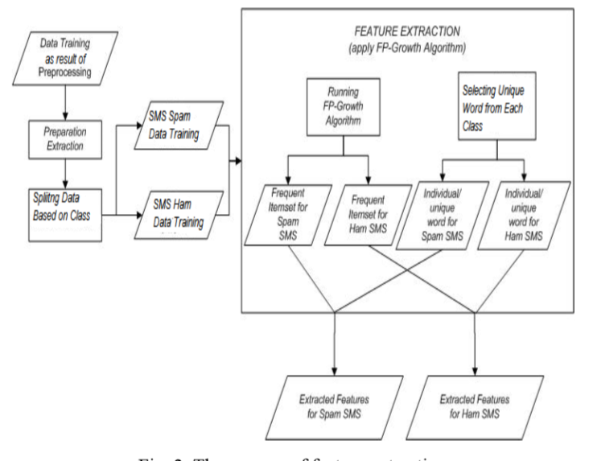

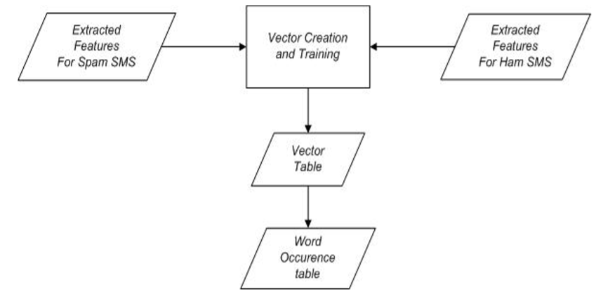

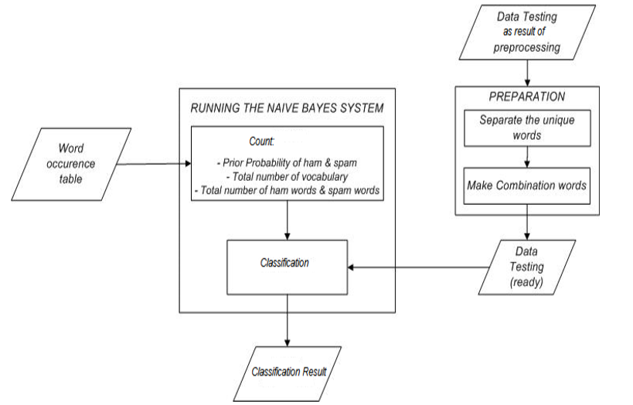

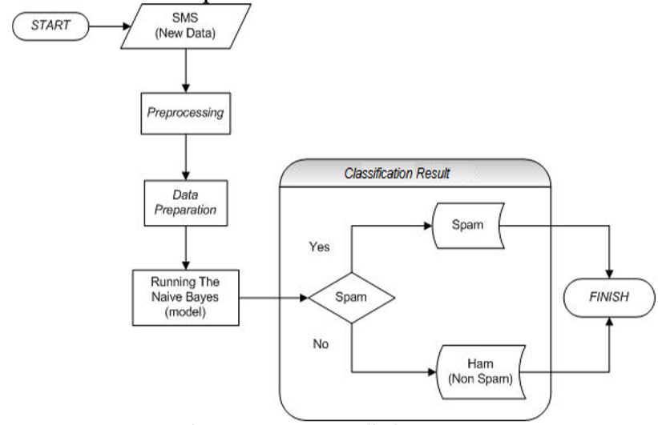

**5 Testing and Debugging**

**5.1 Introduction to Testing:**

**Test for the spam messages:**

It’s one of the most dreaded words in the [email](https://www.emailonacid.com/blog/email-marketing) marketing industry.

We’ve talked a lot about testing your design, but it’s also important to run spam tests to check your email’s deliverability potential.

A spam test checks your email to see whether certain spam filters will flag it and move it out of a subscriber’s inbox. The test looks at the content of your email and where you are sending it from. There are a couple of different ways to check your email for spam potential. If you’re using Email on Acid to test your emails, you can run a spam test with a seed list, run it through your smtp server, or send the test from our servers. This test is more thorough in checking for different aspects of your email that could flag it as spam; the test will not only review your content and subject line, it will also check if your IP address or domain is blacklisted. Seed list testing also provides more accurate test results.

We tested the database and found out that which message is spam and which message is non-spam indicated as 0 and 1 respectively we calculated the feature vector to know whether it is spam or non-spam using that feature vector naive Bayes algorithm works by comparing the trained data to test the data.

**Data set:** Data set is the collection of data or related information that is composed for separate elements a collection of dataset for the message spam contain spam and non-spam messages

* Specific details of the SMTP protocol (did the sender do an HELO, EHLO, and what with name or IP, etc)
* Attributes of the sending domain's DNS (does it resolve, SPF records, domain-keys records)
* Reachability of the sender's MX (for reverse-path verification)
* Source IP address of the server delivering the message
* Content of the message
* An "opinion" that third-party databases or "signatures" give about any of the above (DNSBLs, proprietary "reputation" databases, etc)

Mocking up delivery of messages to a filtering tool becomes less representative of reality if any of these factors aren't the same as what would occur during "real" delivery. Sending captured incoming email to a filtering rig in a manner that doesn't simulate the source IP address of the sending server, for example, impedes that filtering product's ability to act on that factor (running it by a DNSBL, etc). Likewise, sending delayed messages to a filtering (say you have a "canned" corpus of messages to test with) will give a false impression of behavior because the attributes of the sender's DNS and of any third-party databases or signatures may have changed since the time the message was originally sent (sender altered their SPF records to prevent false positives, a third-party service "blacklisted" the sender, etc).

I'd argue that it's impossible to completely mock-up reality, as it comes to delivery. Getting close going to be fairly difficult if you intend to simulate the sending server's IP address (and I'm not aware of any "off the shelf" solution that does that... and having gotten fairly good results from DNSBLs, I'd be concerned about not simulating the sending server's IP address.) Ultimately, you'll just have to get as close as you can afford.

## **Storage**

You've got to stored the filtered email somewhere if you intend to analyze the results. Without storage of some kind there's no good way to actually view the results. Sure, the filtering software generates statistics, but it would certainly improve my comfort-level if I could see the filtered messages.

Some filtering products have a storage capability built-in (like MailMarshal, for example). Other products expect to have an email system to deliver into and don't have any storage capability. To test those products, and so as not to disrupt your production email system, you'll have to create up some kind of secondary email infrastructure to store the test filtering results.

If licensing expense is a concern, you can use free and open source tools to prevent incurring licensing expense. That may present a learning curve for the testing personnel.

More convoluted "groupware"-type email systems may present a challenge in mocking-up because of their dependencies on other services. Exchange Server will require you to mock-up an Active Directory infrastructure to host the mailboxes. Other "groupware"-type email systems (Notes, Groupwise, etc) will have their own associated degrees of difficulty in creating parallel infrastructures.

Scroll through your inbox and look for junk email to see whether your spam filter is performing as expected. If you find spam, use the management tools in your particular program to flag those emails and then create new spam filter rules to manage them.

Check the Spam, Junk and Trash folders to determine if your spam filter is moving email designated as spam to the correct areas.

Send yourself an email that contains one or more words or phrases in the Subject line or message body that you previously set your spam filter to identify as spam, such as “Free,” “Please Read This Immediately!” or “You’ve Won!” Wait a minute or two and then check to see if the spam transferred to the correct folder.

Set up a new spam filter rule using different words or phrases. Send yourself another test message and check the folders again

Use a second email provider to test if your spam filter is handling blocked email addresses and domains correctly. Set your spam filter to block a secondary email account address or domain. Send an email to your primary account from that secondary account and look to see if your email client filtered the spam correctly

Browse to websites that offer free email testing tools such as Byte plant and GFI (links in resources). Follow the on-screen instructions to test your spam filter.

**Difference between verification, validation and testing:**

Verification is a process in which a design is tested (or verified) against a given specification before manufacturing. This can be done using several methods like software simulations, static formal analysis and FPGA/hardware emulation.

Validation is a process in which the manufactured design is tested for all functional and electrical correctness in a lab set up. This includes having the real chip assembled on a test board or a reference board, running real software/applications and making sure that all features work well.

Testing (or Manufacture testing) mostly involves running certain reliable test patterns on each chip before volume shipment. Once a product is validated and is ready for shipment in large volumes, test patterns are run to identify any defective products during fabrication as well as for “binning” parts for different skews.

Some companies use these terminologies interchangeably. For example, in certain companies Verification is also known as Pre-Silicon Validation and Validation is known as Post-Silicon Validation.

Edit: Expanding this on this short answer, I recently wrote an article on same and got published on Any Silicon platform

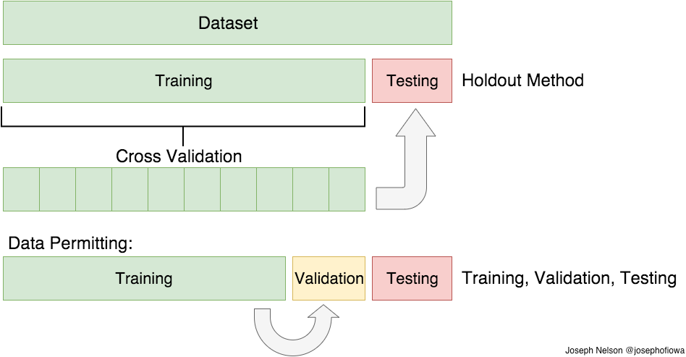

**Fig 1: testing, training and validation**

**Cross Validation:**

In the previous paragraph, I mentioned the caveats in the train/test split method. In order to avoid this, we can perform something called [cross validation](https://en.wikipedia.org/wiki/Cross-validation_(statistics)). It’s very similar to train/test split, but it’s applied to more subsets. Meaning, we split our data into k subsets, and train on k-1 one of those subsets. What we do is to hold the last subset for test. We’re able to do it for each of the subsets.

**Train/Test Split:**

As I said before, the data we use is usually split into training data and test data. The training set contains a known output and the model learns on this data in order to be generalized to other data later on. We have the test dataset (or subset) in order to test our model’s prediction on this subset.

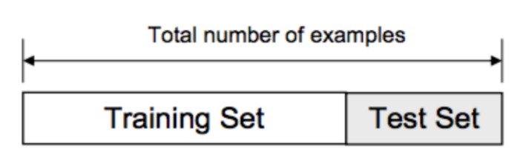

**Fig 2: example for train/test split**

**Training:**

The training data is an initial set of data used to help a program understand how to apply technologies like neural networks to learn and produce sophisticated results. It may be complemented by subsequent sets of data called validation and testing sets.

Training data is also known as a training set, training dataset or learning set.

The training set is the material through which the computer learns how to process information. Machine learning uses algorithms – it mimics the abilities of the human brain to take in diverse inputs and weigh them, in order to produce activations in the brain, in the individual neurons. Artificial neurons replicate a lot of this process with software – machine learning and neural network programs that provide highly detailed models of how our human thought processes work.

With that in mind, training data can be structured in different ways. For sequential decision trees and those types of algorithms, it would be a set of raw text or alphanumerical data that gets classified or otherwise manipulated. On the other hand, for convolutional neural networks that have to do with image processing and computer vision, the training set is often composed of large numbers of images. The idea is that because the machine learning program is so complex and so sophisticated, it uses iterative training on each of those images to eventually be able to recognize features, shapes and even subjects such as people or animals. The training data is absolutely essential to the process – it can be thought of as the “food” the system uses to operate.

Training data is the main and most important data which helps machines to learn and make the predictions. This data set is used by machine learning engineer to develop your algorithm and more than 70% of your total data used in the project.

**Difference between testing and trained data:**

Training set is the one on which we train and fit our model basically to fit the parameters.

Test data is used only to assess performance of model. Training data's output is available to model whereas testing data is the unseen data for which predictions have to be made.

**TRAINING PHASE**:

A phase where you are basically training the algorithms to create the right output. In the in the learning phase you are having the input parameters. ... While training, the algorithm modifies the training parameters. It also modifies the used data and then you are getting to an output.

[Software Testing](https://www.edureka.co/blog/what-is-software-testing/) is a process of evaluating the functionality of a software application to find any software bugs. It checks whether the developed software met the specified requirements and identifies any defect in the software in order to produce a quality product.

This is basically executing a system in order to identify any gaps, errors, or missing requirements contrary to the actual requirements. It is also stated as the process of verifying and validating a software product. With this, you can check whether the software product:

* Meets the business and technical requirements that guided its design and development
* Works as per the requirement
* Can be implemented with the same characteristics

## **Software Testing Strategies**

An efficient [software testing](https://www.edureka.co/blog/test-plan-in-software-testing/) or QA strategy requires testing of all technology stack levels to ensure that every part, as well as the entire system, works without breaking down. Some of the Software Testing Strategies include:

**5.2 Dimensions of Testing:**

**1)Demonstrate, Check, Confirm, Verify, Validate**

First of all testing is about demonstrating in a constructive way that something works, at least to some extent. Further it is about checking and confirming artifacts like requirements, features or use cases. And it is also about verifying and validating.

**2)Detect, Search**

In testing we try to detect bugs as early as possible in a destructive way, and we search for unknown and therefore unspecified behaviour in the system under test**.**

**3)Mitigate, Reduce Risks, Investigate, Explore**

Any testing should be based on risks in the system under test, so this is also a very important dimension in testing. Thereby we also investigate and explore in order to look deep inside the system under test.

**4)Measure, Assess, Evaluate and Predict**

During testing we collect data and measure, for example to address quality attributes like performance, reliability or availability. Based on these data we know something about the current status, and we can hopefully make a good forecast for the future.

**5.3 Stages of Testing:**

Testing Stage 1 – Test Plan

Software testing should always begin with establishing a well thought-out test plan to ensure an efficient execution of entire testing process. Efficient test plan must include clauses concerning the amount of work to be done, deadlines and milestones to be met, methods of testing and other formalities like contingencies and risks.

Testing Stage 2 – Analysis

At this stage, functional validation matrix is made. In-house or [offshore testing team](https://testfort.com/) analyzes the requirements and test cases which are to be automated and which are to be tested manually.

Testing Stage 3 – Design

If the testing team has reached this stage it means that there is no confusion or misunderstanding concerning the test plan, validation matrix or test cases. At Designing Stage testing team makes suitable scripts for automated test cases and generates test data for both automated and manual test cases.

Testing Stage 4 – Development

At this stage, scripting is provided. In particular cases, development stage also includes unit tests and generating of performance and stress test plans. Usually it happens when testing starts together with the software development process.

Testing Stage 5 – Execution

As soon as the entire scripting have been made its execution begins. Firstly, testing team executes unit tests, and then functionality tests. They identify bugs on the superficial level and report to the

software developers. After that the detailed testing is carried out. Execution stage is completed when test and bug reports are made up.

Testing Stage 6 – Bug fixing

When testing team identifies the bugs, they send it to [IT development team](https://qarea.com/). If development team considers to fix the bugs, testing team has to retest the software in order to check that no new bugs have been created while fixing.

Testing Stage 7 – Software is implemented

This is the final stage of the software testing when all test cases are executed and all procedures are carried out. The software is delivered to the end user who tests it and reports if any bugs take place.

**5.4 Types of Testing**

**5.4.1 Unit Testing**

Unit testing involves the design of test cases that validate that the internal program logic is functioning properly, and that program inputs produce valid outputs. All decision branches and internal code flow should be validated. It is the testing of individual software units of the application .it is done after the completion of an individual unit before integration. This is a structural testing, that relies on knowledge of its construction and is invasive. Unit tests perform basic tests at component level and test a specific business process, application, and/or system configuration. Unit tests ensure that each unique path of a business process performs accurately to the documented specifications and contains clearly defined inputs and expected results.

**5.4.2 Integration Testing**

Integration testing addresses the issues associated with the dual problems of verification and program construction. After the software has been integrated a set of high order tests are conducted. The main objective in this testing process is to take unit tested modules and builds a program structure that has been dictated by design.

**5.4.3 System Testing**

System testing ensures that the entire integrated software system meets requirements. It tests a configuration to ensure known and predictable results. An example of system testing is the configuration oriented system integration test. System testing is based on process descriptions and flows, emphasizing pre-driven process links and integration points.

**5.4.4 Interface Testing:** When an application or a software or a website is developed, then there **are** several components of it. Those components can be server, database etc. The connection which integrates and facilitates the communication between these components is termed as an Interface. It verifies that communication between the systems are done correctly.

**3 phases of Interface Testing**

1. **Configuration & development** -When the interface is configured, and once the development starts, the configurations need to be verified as per the requirement.
2. **Validation –**When the development is completed, the interface needs to be validated and verified, this can be done as a part of unit testing also.
3. **Maintenance –**When we start developing an interface, we need to make sure that we are not introducing any defects in our code and hence tests need to be run on the interface.

**5.4.5 User Acceptance Testing:**

Acceptance Testing is a level of software testing where a system is tested for acceptability. The purpose of this test is to evaluate the system’s compliance with the business requirements and assess whether it is acceptable for delivery

1. **Alpha Testing –**This is to assess the Product in the development/testing environment by a specialized testers team usually called alpha testers.
2. **Beta Testing –**This is to assess the Product by exposing it to the real end-users, usually called beta testers/beta users, in their environment. Continuous feedback from the users is collected and the issues are fixed.

**5.4.6 White Box Testing:**

White Box Testing is a testing in which in which the software tester has knowledge of the inner workings, structure and language of the software, or at least its purpose. It is purpose. It is used to test areas that cannot be reached from a black box level.

**5.4.7: Black Box Testing:**

Black Box Testing is testing the software without any knowledge of the inner workings, structure or language of the module being tested. Black box tests, as most other kinds of tests, must be written from a definitive source document, such as specification or requirements document, such as specification or requirements document. It is a testing in which the software under test is treated, as a black box .you cannot “see” into it. The test provides inputs and responds to outputs without considering how the software works.

**6.Output Screens:**

**Screen shots for the project of spam detection on mobiles**

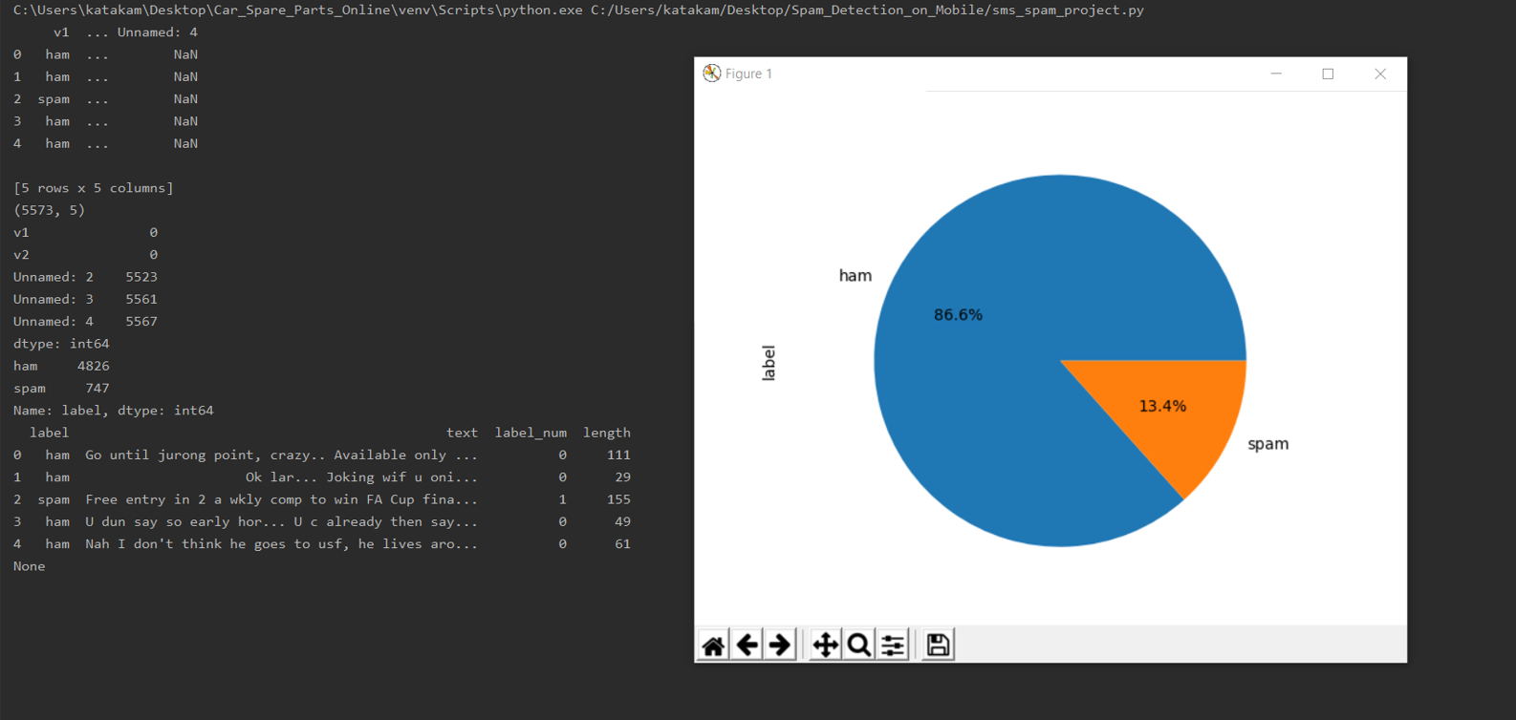

The above pie graph is divided into two sectors one is spam and the other is ham that each represent a proportion of the whole. This organize the data in order to see the size of components relative to the whole and also it shows the percentage of the data

The above pie graph shows the two types of messages i.e., spam and ham. The 13.4% of entire circle are spam mails and 86.6% of the entire circle are ham messages. Here ham is nothing but good messages and spam is fraud messages. The dataset used in this work is verified and analyzed using previously listed eleven different machine learning base classification techniques

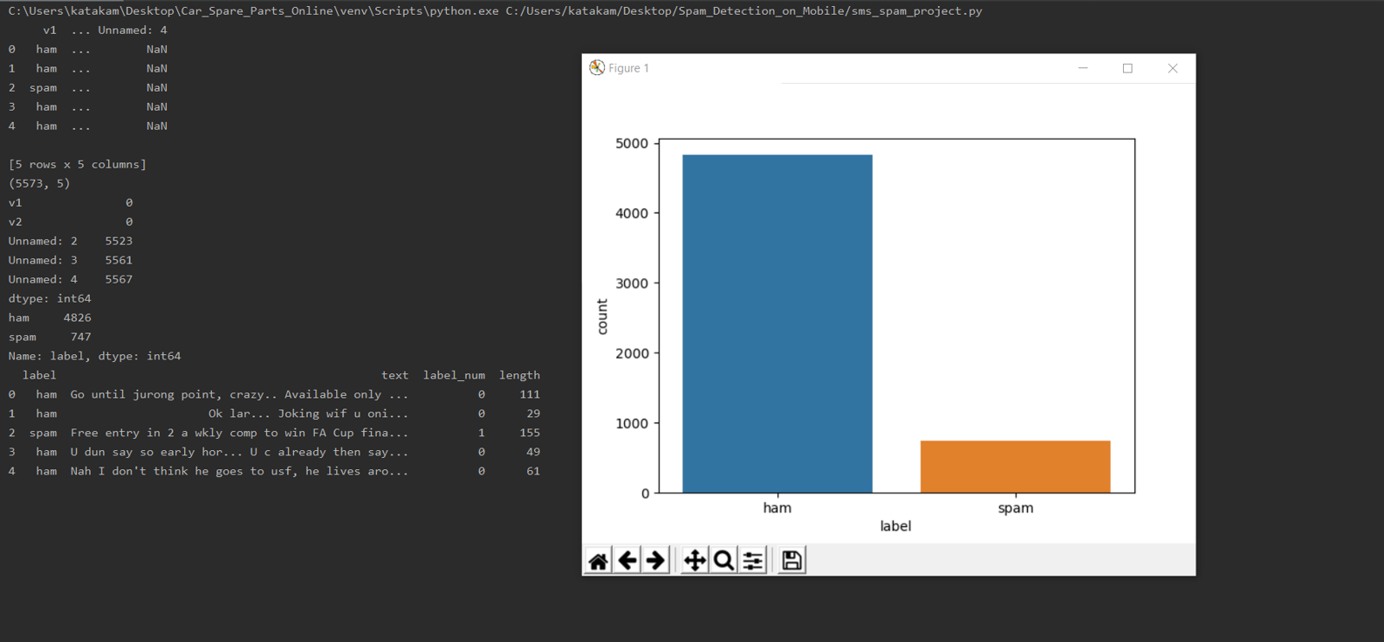

The cause of this Project is to discover the effects of making use of gadget gaining knowledge of techniques to discover Message spam detection. SMS unsolicited mail (every now and then known as cell smartphone junk mail) is any junk message brought to a cellular phone as textual content messaging via the Short Message Service (SMS). The dataset for this mission originates from the UCI Machine Learning Repository.

Using special techniques to establish relation between the textual content and the category SPAM or HAM like, primarily based on length of message, word depend, unique keywords. Then construct class fashions the use of one-of-a-kind strategies to differentiate spam SMS.

Compare accuracy of each method and plot the accuracy graphs in a single bar plot. Also generate a phrase-cloud for junk mail SMS. For given dataset, we will compare with different algorithms and checks which algorithm gives the better accuracy whether the message contains HAM or SPAM. Total Dataset: 5572 HAM messages: 4825 SPAM messages: 747 After training and testing the dataset, the messages will be split

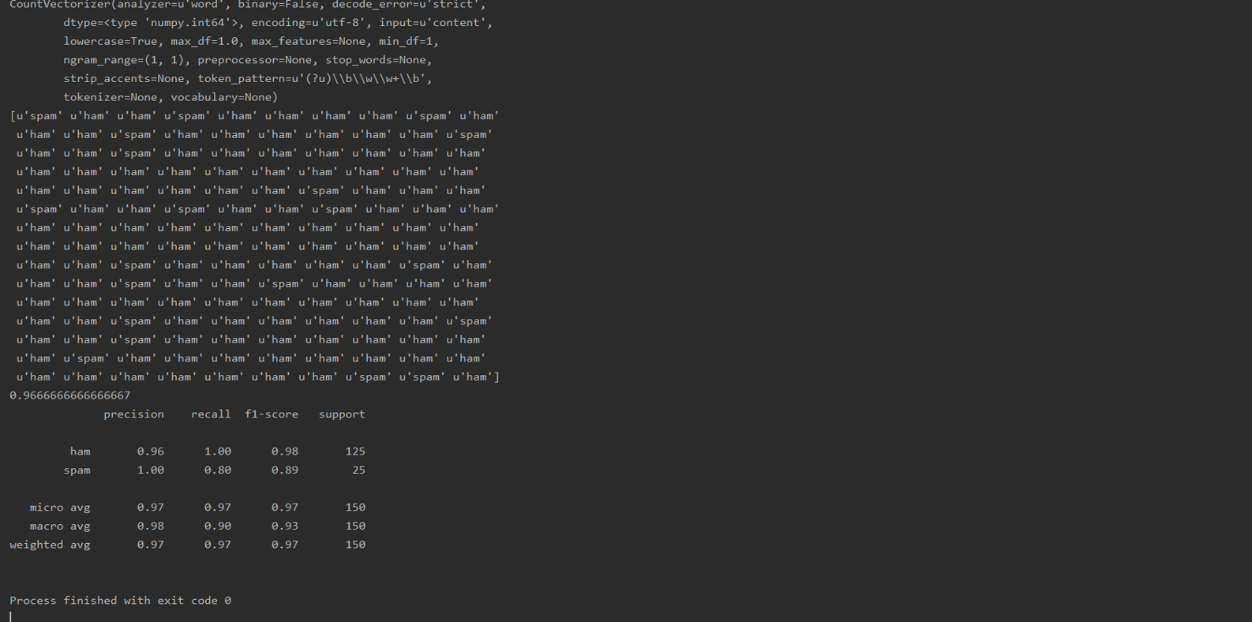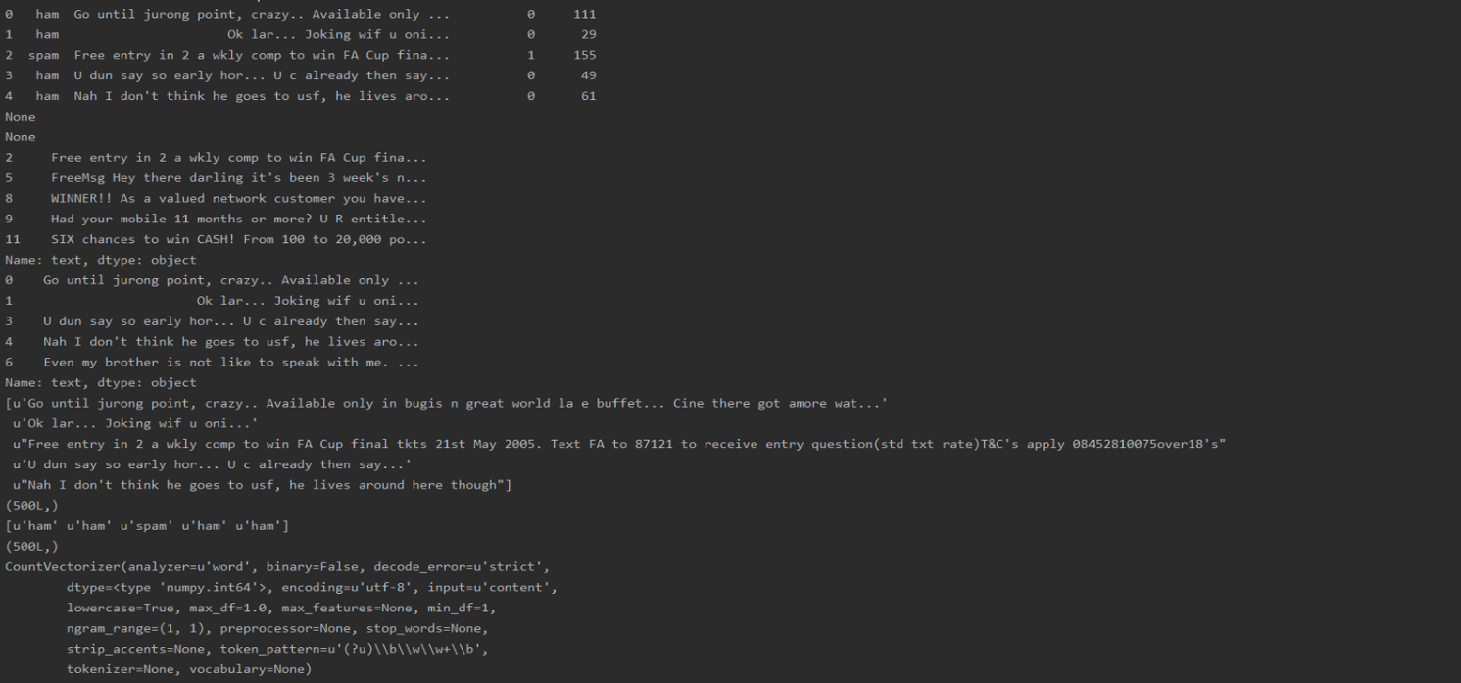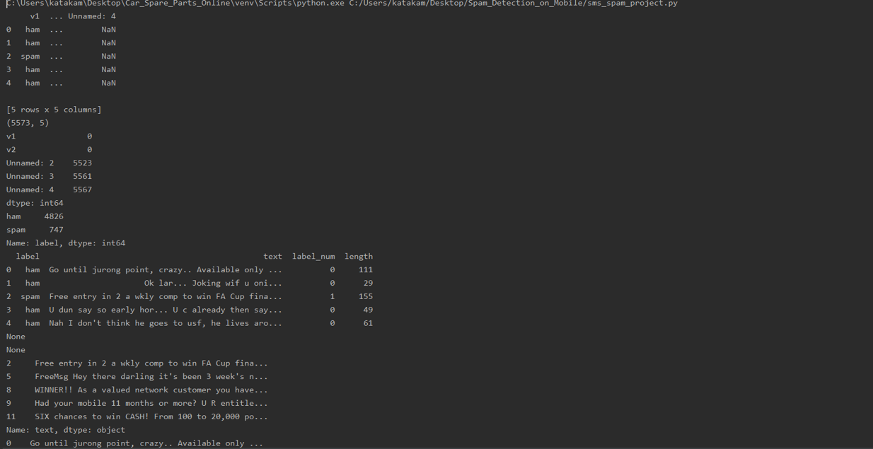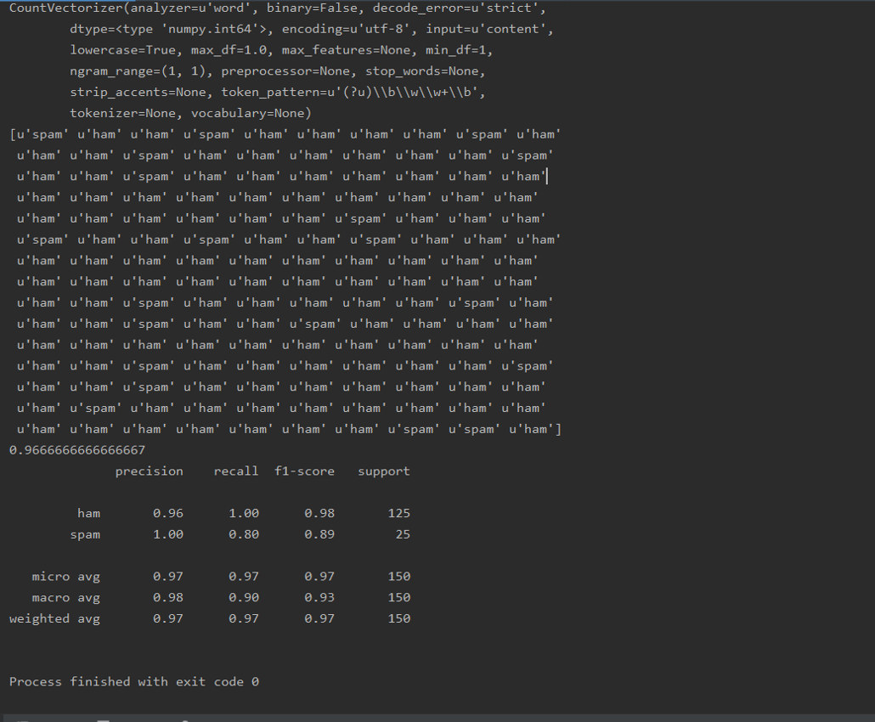

**Precision:** Gives us the ratio of cases where the number of spam classifications by the model to the actual number of spams in the data.

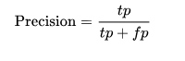

Precision= spams correctly classified / (spams correctly classified + emails incorrectly labeled as spam)

If we classify all the emails as not spam we would have an high accuracy considering that there are more numbers of hams as compared to spams but that model would have a very low precision and recall. If we identify one email correctly as spam we have precision of 100% (false positives =0, true positives =1), but recall would be extremely low because of high number of false negatives. So a model with only high precision also does not make a lot of sense.

Fortunately statistics comes to our rescue and gives us a way to combine recall and precision to get a new parameter called balanced F- score. F- score is the harmonic mean of recall and precision.

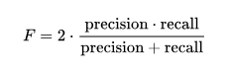

**Fi-score**: An F- score gives equal importance to precision and recall both which in some cases leads to bias between classes. To accommodate this, there have been two variations of F measure, F2 score- places more importance on recall than precision and f(0.5) score which gives more importance to precision than recall.

A ROC curve is a very effective to visualize the diagnostic ability of a classifier. It is plotted between True Positive rate (Recall) and False Positive rate (probability of false alarm).

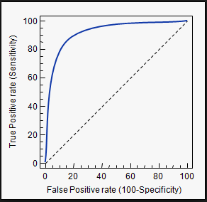

**Fig 1: Display of Fi-score**

**Recall:** The statistical term for identifying all the useful cases is called



Recall = spams correctly identified / (spams correctly identified + spams incorrectly identified as ham)

Now if we classify all emails as spam, we will have a recall of 1, seems tempting right but that would fail our purpose. It would create a very low precision in our model.

As mentioned, in statistics and machine learning we usually split our data into two subsets: training data and testing data (and sometimes to three: train, validate and test), and fit our model on the train data, in order to make predictions on the test data. When we do that, one of two things might happen: we overfit our model or we underfit our model. We don’t want any of these things to happen, because they affect the predictability of our model — we might be using a model that has lower accuracy and/or is un generalized (meaning you can’t generalize your predictions on other data).

**7.Conclusion:**

Based on the analysis of the tests performed in this research, it can be concluded that:

Both methods used in this research, the performances of both methods is equally well for SMS classification with average of the accuracy above 90%. The use of collaboration methods, Naive Bayes and FP-Growth, is superior to the average accuracy for each dataset.

The Accuracy best average is obtained when the SMS Spam Collection v.1 dataset with the 9%minimum support is used and the implementation of the FP-Growth has accuracy up to 98.506%.

The use of datasets with varied training data is agreeable to be applied by using the FP-Growth. By implementing the FP-Growth for feature extraction, it can elevate the score of precision. Thus, the system becomes more precise in providing the information requested by the users in response to the SMS classification.

**8.Future Enhancement:**

1. Though, thesis has made efforts towards solving the problem of Spam E-mail using legislative, behavioral and technological measures, the solution proposed are not complete solutions.
2. The problem of Spam E-mail and Anti-Spam solution is game of cat and mouse since, every day Spammer will come up with new techniques of sending Spam E-mails. This work has given the potential direction for classification of the Spam E-mails.

**The future efforts would be extended towards:**

1. Achieving accurate classification, with zero percent (0%) misclassification of Ham E-mail as Spam and Spam E-mail as Ham.
2. The efforts would be applied to block Phishing E-mails, which carries the phishing attacks and now-days which is more matter of concern.
3. Also, the work can be extended to keep away the Denial of Service attack (DoS) which has now, emerged in Distributed fashion called as Distributed Denial of Service Attack (DDoS).
4. Getting caught in the spam folder is an email marketer’s nightmare, but it’s more common than you might think. If you’re not watching and paying attention, it’s easy to get your emails blocked or blacklisted and not know it. Or there might be issues with your infrastructure or the content of your email that can trigger spam filters, preventing your messages from being delivered to the inbox.
5. But how do you know if your email is at risk of being sent to the spam folder? Spam filter testing tools are instrumental in getting this critical visibility.
6. We asked thousands of marketers if they run their emails through spam filter tests before sending—and which tools they use to do so. Here’s what we found.
7. [53.8%](https://litmus.com/ebooks/state-of-email-analytics/)**of all marketers say they rely on spam filter testing tools** to test their emails for potential spam issues before they send**,**according to our [State of Email research](https://litmus.com/ebooks/state-of-email-analytics/). Third-party spam testing tools are the most popular, with [37.7%](https://litmus.com/ebooks/state-of-email-analytics/) of brands using them. Another [16.1%](https://litmus.com/ebooks/state-of-email-analytics/) of brands rely on the spam testing tools provided by their email service providers (ESPs) for pre-send spam testing.
8. Marketers who use third-party spam filter testing tools are 50% more likely to report being blacklisted ([22% vs. 15%](https://litmus.com/ebooks/state-of-email-analytics/)) than those who don’t.
9. But that doesn’t mean that those brands get blacklisted more often. It’s safe to assume that most of these differences are due to tool users having much better visibility into their deliverability. After all, you can’t report or resolve a blacklisting if you aren’t aware of it.
10. Here’s another stat that supports that theory: Brands who use spam filter tests before sending emails [reported an ROI of 51:1](https://litmus.com/leadership/email-marketing-roi), while those who don’t report an ROI of 39:1. Having better visibility into blocks and black listings means you can take action more quickly—and that leads to better email program performance.

## THE MOST POPULAR SPAM FILTER TESTING TOOLS

1. Many brands use third-party tools in addition to their ESP’s functionality to prevent blocking and blacklisting. Out of the 600+ marketers that said they use third-party spam filter testing tools, over half ([59.6%](https://litmus.com/ebooks/state-of-email-analytics/)) relies on [Litmus Spam Testing](https://litmus.com/spam-filter-tests) to ensure their emails pass spam filter tests prior to sending an email.

Several studies have been carried out on machine learning techniques and many of these algorithms are being applied in the field of email spam filtering. Examples of such algorithms include Deep Learning, Naïve Bayes, Support Vector Machines, Neural Networks, K-Nearest Neighbor, Rough sets, and Random Forests

**9. References:**

<https://ieeexplore.ieee.org/abstract/document/7811442/>

<https://onlinelibrary.wiley.com/doi/full/10.1002/sec.577>

**Books to refer**:

**Advance image-based spam detection and filtering techniques**

**-** Dhavale, Sunita Vikrant

**Spam assassin**

**-**alan schwartz

**10 Appendix-A**

**Overview of Python:**

Python is a high-level, interpreted, interactive and object-oriented scripting language. Python is designed to be highly readable. It uses English keywords frequently whereas the other languages use punctuations. It has fewer syntactical constructions than other languages.

**History of Python:**

Python was developed by Guido Van Rossum in the late eighties and early nineties at the National Research Institute for Mathematics and Computer Science in the Netherlands.

Python is derived from many other languages, including ABC, Modula-3, C, C++, Algol-68, Small Talk, and Unix shell and other scripting languages.

**Python Features:**

* **Portable:** Python can run on a wide variety of hardware platforms and has the same interface on all platforms
* **Extendable:** You can add low level modules to the python interpreter. These modules enable programmers to add to or customize their tools to be more efficient.
* **Scalable:** Python provides a better structure and support for large programs than shell scripting.
* **Interactive Mode:** Pythonhas support for an interactive mode, which allows interactive testing and debugging of snippets of code**.**
* It supports functional and structured programming methods as well as OOP.
* It can be used as scripting language or can be compiled to byte-code for building large applications.
* It provides very high-level dynamic data types and supports dynamic type checking.
* It can be easily integrated with C, C++, COM, ActiveX, CORBA, and Java.

**Overview of NumPy:**

NumPy, which stands for Numerical Python, is a library consisting of multidimensional array objects and a collection of routines for processing those arrays.

**Operations of NumPy:**

* Mathematical and logical operations on arrays.
* Fourier transforms and routines for shape manipulation.
* Operations related to linear algebra. NumPy has in-built functions for linear algebra and random number generation.

**Overview of Pandas:**

Pandas is an open source python library providing high performance, easy to use data structures and data analysis tools for the python programming language.

## **Key Features of Pandas**

* Fast and efficient Data Frame object with default and customized indexing.
* Tools for loading data into in-memory data objects from different file formats.
* Data alignment and integrated handling of missing data.
* Reshaping and pivoting of date sets.
* Label-based slicing, indexing and sub-setting of large data sets.
* Columns from a data structure can be deleted or inserted.
* Group by data for aggregation and transformations.
* High performance merging and joining of data.
* Python is a general-purpose interpreted, interactive, object-oriented, and high-level programming language. An [interpreted language](https://en.wikipedia.org/wiki/Interpreted_language), Python has a design philosophy that emphasizes code [readability](https://en.wikipedia.org/wiki/Readability) (notably using [whitespace](https://en.wikipedia.org/wiki/Whitespace_character) indentation to delimit [code blocks](https://en.wikipedia.org/wiki/Code_block) rather than curly brackets or keywords), and a syntax that allows programmers to express concepts in fewer [lines of code](https://en.wikipedia.org/wiki/Source_lines_of_code) than might be used in languages such as [C++](https://en.wikipedia.org/wiki/C%2B%2B)or [Java](https://en.wikipedia.org/wiki/Java_(programming_language)). It provides constructs that enable clear programming on both small and large scales. Python interpreters are available for many [operating systems](https://en.wikipedia.org/wiki/Operating_system). [CPython](https://en.wikipedia.org/wiki/CPython" \o "CPython), the [reference implementation](https://en.wikipedia.org/wiki/Reference_implementation) of Python, is [open source](https://en.wikipedia.org/wiki/Open_source) software and has a community-based development model, as do nearly all of its variant implementations. CPython is managed by the non-profit [Python Software Foundation](https://en.wikipedia.org/wiki/Python_Software_Foundation). Python features a [dynamic type](https://en.wikipedia.org/wiki/Dynamic_type) system and automatic [memory management](https://en.wikipedia.org/wiki/Memory_management). It supports multiple [programming paradigms](https://en.wikipedia.org/wiki/Programming_paradigm), including [object-oriented](https://en.wikipedia.org/wiki/Object-oriented_programming), [imperative](https://en.wikipedia.org/wiki/Imperative_programming), [functional](https://en.wikipedia.org/wiki/Functional_programming) and [procedural](https://en.wikipedia.org/wiki/Procedural_programming), and has a large and comprehensive [standard library](https://en.wikipedia.org/wiki/Standard_library)
* **DJANGO**
* Django is a high-level Python Web framework that encourages rapid development and clean, pragmatic design. Built by experienced developers, it takes care of much of the hassle of Web development, so you can focus on writing your app without needing to reinvent the wheel. It’s free and open source.
* Django's primary goal is to ease the creation of complex, database-driven websites. Django emphasizes [reusability](https://en.wikipedia.org/wiki/Reusability" \o "Reusability)and "pluggability" of components, rapid development, and the principle of [don't repeat yourself](https://en.wikipedia.org/wiki/Don%27t_repeat_yourself). Python is used throughout, even for settings files and data models.
* 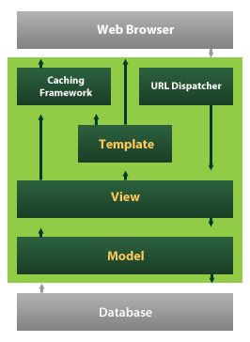
* Django also provides an optional administrative [create, read, update and delete](https://en.wikipedia.org/wiki/Create,_read,_update_and_delete) interface that is generated dynamically through [introspection](https://en.wikipedia.org/wiki/Introspection_(computer_science)) and configured via admin models
* 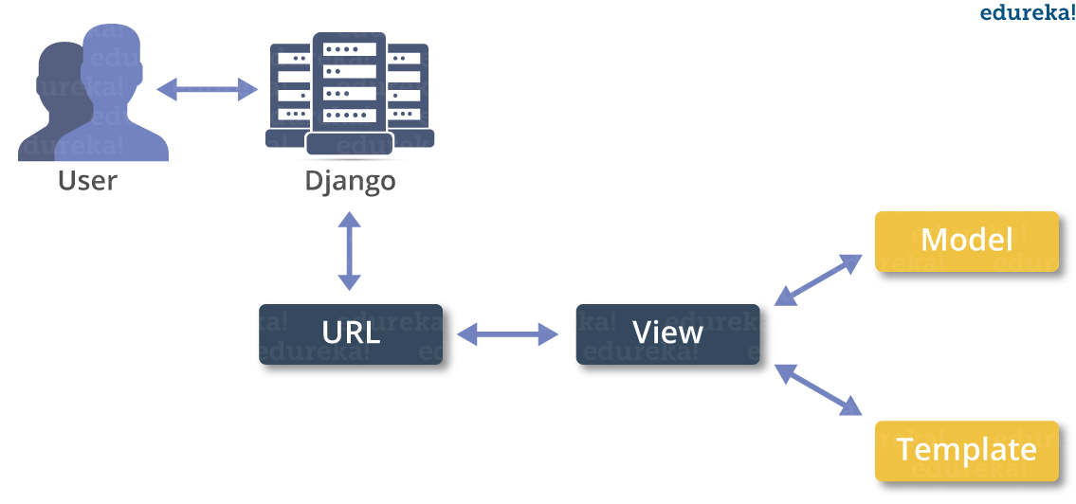

**11.Appendix-B**

# importing Modules  
import pandas as pd  
import numpy as np  
import matplotlib.pyplot as plt  
  
#read csv file  
data=pd.read_csv("spam.csv",encoding="latin_1")  
print(data.head())  
  
#find no.of rows and columns  
print(data.shape)  
  
#find if any NaN numbers is there in data  
print(data.isnull().sum())  
  
#Drop NAN Number columns  
data = data.drop(["Unnamed: 2", "Unnamed: 3", "Unnamed: 4"], axis=1)  
  
#column names rechange  
data = data.rename(columns={"v1":"label", "v2":"text"})  
  
#Count observations in each label  
print(data.label.value_counts())  
  
# convert label to a numerical variable  
data['label_num'] = data.label.map({'ham':0, 'spam':1})  
data['length'] = data['text'].apply(len)  
print(data.head())  
  
# importing the seaborn for ploting the graph  
import seaborn as sns  
sns.countplot(data["label"])  
print(plt.show())  
data["label"].value_counts().plot(kind="pie",autopct="%1.1f%%")  
plt.axis("equal")  
print(plt.show())  
  
#checking how many spam mails are there  
spam1=data.loc[data['label']=='spam']  
print(spam1["text"].head())  
  
#checking how many ham mails are there  
ham1=data.loc[data['label']=='ham']  
print(ham1["text"].head())  
  
# Assume x value as a input   
x=np.array(data.iloc[0:500,1])  
print(x[0:5])  
print(x.shape)  
  
# assume y value as target value  
y=np.array(data.iloc[0:500,0])  
print(y[0:5])  
print(y.shape)  
  
#importing the Sklearn module  
from sklearn.model_selection import train_test_split  
x_train,x_test,y_train,y_test=train_test_split(x,y,test_size=0.3,random_state=1)  
  
# importing the CountVector from Feature extraction  
from sklearn.feature_extraction.text import CountVectorizer  
count_vector = CountVectorizer()  
print(count_vector)  
  
#apply count vector to convert text data vector format like 0s and 1s  
train_data = count_vector.fit_transform(x_train)  
test_data = count_vector.transform(x_test)  
  
# importing the naive bayes algorithm form sklearn  
from sklearn.naive_bayes import MultinomialNB  
model=MultinomialNB()  
model.fit(train_data,y_train)  
  
#find the prediction   
pred=model.predict(test_data)  
print(pred)  
  
#checking accuracy  
from sklearn.metrics import accuracy_score  
score=accuracy_score(pred,y_test)  
print(score)  
  
# Testing  
from sklearn.metrics import classification_report  
nbreport=classification_report(y_test, pred)  
print(nbreport)  
  
from sklearn.metrics import f1_score  
from sklearn.metrics import recall_score  
from sklearn.metrics import precision_score  
  
  
# Capture the original matplotlib rcParams  
import matplotlib as mpl  
_orig_rc_params = mpl.rcParams.copy()  
  
# Import seaborn objects  
from .rcmod import *  
from .utils import *  
from .palettes import *  
from .relational import *  
from .regression import *  
from .categorical import *  
from .distributions import *  
from .timeseries import *  
from .matrix import *  
from .miscplot import *  
from .axisgrid import *  
from .widgets import *  
from .colors import xkcd_rgb, crayons  
from . import cm  
  
__version__ = "0.9.0"

